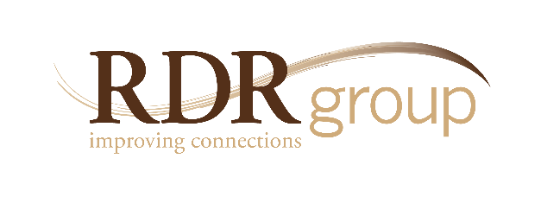

Connecting with Others:
Reaching Performance Potential Through Inclusion

5250 Grand Ave. • Ste.14 #206 Gurnee, IL • 60031-1877
Ph. 815-477-2330 • Fax 2335
www.rdrgroup.com

“Connecting with Others” is a workshop that takes diversity training to a whole new level.
Numerous clients report that this course received higher ratings than any program they have ever sponsored. It is dynamic, engaging and practical.
THE FOCUS
Instead of just introducing new concepts, this course focuses on specific competencies which create sustainable culture change around inclusion and diversity. The class goes beyond awareness and looks at 5 strategic skills which are necessary to connect with a wider scope of individuals – causing a marked improvement in employee engagement, customer satisfaction and overall performance.

Introduction
The “Connecting” workshop is framed in the context of creating a user-friendly workplace for everyone - both employees and customers – regardless of differences.
The importance of connecting has everything to do with successful outcomes.

Re-defining diversity and inclusion
Although issues of race and gender are not neglected in this workshop – diversity is a much broader concern. A new
definition is therefore presented as “any difference that makes a difference”. This allows participants to consider what differences might be causing disconnects for them and the organization. By the same token, inclusion is not about having diversity – it’s about valuing differences in a way that helps everyone succeed.

Building the Business Case
Various studies are examined to demonstrate the criticality of connecting. This includes the research from the Gallup Q-12 and The Great Place to Work Institute which shows a powerful link between inclusion and productivity, profitability, retention and customer service. Participants are also asked to build their own case by brainstorming around the question: what is the impact on employees, customers and the organization, when people disconnect?

Evaluating the Current State
Assessment tools are provided to determine how people feel about themselves and the organization when it comes to connecting. They are challenged to play their part
in improving the connections.

Five Disconnects and the Corresponding Competencies
Disconnect: Flocking – gravitating toward those with similar interests.
1
Competency: Networking – expanding our circle with those who are different.
2

Disconnect: Cultural Naiveté – causing offense without intending to.
Competency: Sensitivity – awareness of our interactions.
Disconnect: Monoculturalism – expecting conformity to a single approach.
3
Competency: Calibration – adjusting for differences and altering our approach.
Disconnect: Pejorative Behavior – showing or tolerating overt disrespect.
4
Competency: Advocacy – taking a stand and addressing inappropriate behavior.
Disconnect: Unconscious Filtering – making assumptions based on stereotypes.
5
Competency: Positive Expectancy – assuming the best of others and acting on it.

Skill Building and Action Planning
- Repairing Disconnects – a three-step process for addressing a disconnect is presented which involves: taking initiative, exploring the issues and creating cooperation to repair the problem.
- Improving Connections – participants are asked to work together to analyze situations where they could afford to connect better with someone else. Each person creates
a brief action plan that enumerates ways they can strengthen their connections.
- Application – participants formulate specific action plans to ensure that the five competencies are put into practice in reference to employee and customer relations.

