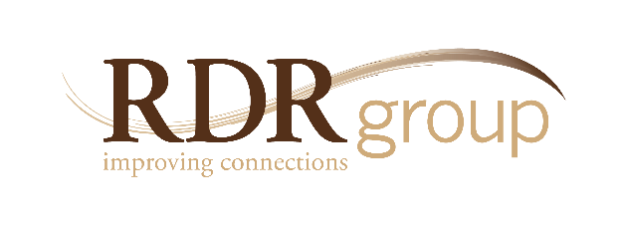

Healthy Interactions:
Managing Unconscious Bias

5250 Grand Ave. • Ste.14 #206 Gurnee, IL • 60031-1877
Ph. 815-477-2330 • Fax 2335
www.rdrgroup.com

THE NEED
The challenge of effective public service among increasingly diverse communities is greater than ever before.

Maintaining healthy interactions with those inside (and outside) the organization requires a new set of skills so that people are proactive, rather than reactive, when
responding to differences.

This course allows participants to honestly explore the hidden biases that are common to all of us and to develop greater self-control over emotional reactions that can negatively impact employee relations and public relations.

Introduction
- To begin with, we frame this course in the context of achieving successful outcomes for individuals and for the organization through improving interactions with a wider scope of people. We'll define terms and give them texture through real-world scenarios.

- We define "diversity" as any difference that makes a difference, so that participants can assess what issues may or may not be a problem; we define "inclusion" as healthy interactions as a way of acknowledging that all people don't feel the same level of connection.

The Case for Healthy Interaction
- To Participants will brainstorm around this question: "What is the impact of healthy versus unhealthy interactions, both internally (within the organization) and externally (within the community)?" This exercise allows them to see the importance of healthy interactions in reaching personal and organizational objectives.

- We present a model called "The Success Cycle" that illustrates the relationship between healthy interactions and outcomes.

- The central point is to be mature and proactive when responding to differences while avoiding what's called the "limbic brain response," which is more reactive. We bring in various studies and group activities to reinforce this point.

Breaking Through Denial

- We ask participants to rate themselves and the "inclusivity" of the organization in three areas.
- Knowing the triggers - those catalysts that might set people off (in society and at work).

Behaviors That Cause Healthy and Unhealthy Interactions

Unhealthy | Healthy
Flocking - gravitating toward those with similar interests. | Networking - expanding your circle with those who are different.
Cultural Naiveté - causing offense without intending to. | Sensitivity - raising awareness of how interactions impact others.
Monoculturalism - expecting conformity to a single approach. In this section we often discuss cultural, generational, racial, gender, & lifestyle differences. | Calibration - adjusting for differences and altering our approach.
Pejorative Behavior - showing or tolerating overt disrespect. | Advocacy - taking a stand and addressing inappropriate behavior.
Unconscious Filtering - making assumptions based on stereotypes. | Positive Expectancy - assuming the best of others and acting on it.

Skill Building and Action Planning
- The Connection Simulation—this activity pulls all the learning together and teaches participants experientially the skills needed for healthy interactions.

- Repairing Unhealthy Interactions—we present a three-step process for addressing unhealthy interactions.

- Improving our Interactions—participants are asked to work in groups to analyze any situations where they could afford to connect better with someone else.

- Application—participants formulate specific action plans to ensure that the five healthy behaviors above are put into practice within the organization.

