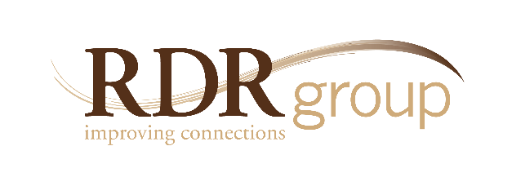

Healthy Boundaries:
Encouraging Positive Behavior at Work

5250 Grand Ave. • Ste.14 #206
Gurnee, IL • 60031-1877
Ph. 815-477-2330 • Fax 2335
www.rdrgroup.com

In an effort to maintain a Culture of Respect – Healthy Boundaries examines interactions on the job that can facilitate (or debilitate) productive outcomes. More significantly, the training is non-threatening, practical and dynamic so participants actually stay engaged enough to learn. The workshop looks at competencies to help participants address inappropriate behavior and create
a more positive work environment.

THE FOCUS
Instead of looking only at the legal parameters, this course examines an entire range of behaviors that either help or hinder successful outcomes at work. The spectrum includes everything from mildly disruptive behavior to harassment, violence and what is appropriate or productive. People clearly need to know the boundaries for what is unhealthy, but placing an emphasis on the positive side will prevent incidents before they impact the organization. The goal then is to get each participant to consider the consequences of what they do when fostering or tolerating a “less-than-positive” atmosphere. It will not only hurt the organization, it will hurt them and their future success – which is why we present this as a performance issue requiring total commitment from everyone to move the needle in the right direction. *(see diagram below)

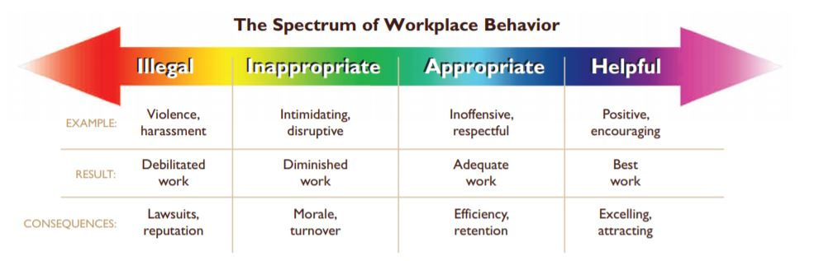

THE NEED
Today’s workplace represents a unique mix of conflicting pressures, personalities and values. As a result, workers often do and say things that are perceived as hostile, offensive and inappropriate. When these occurrences go unchecked, they end up “derailing” careers, reputations and performance results. The fallout is not limited to unwanted lawsuits – indeed, it is often behavior which is not “illegal” that exacts the highest price in terms of stress, morale, and productivity. By contrast, when healthy boundaries are maintained – it allows an organization to achieve its very best.

THE SOLUTION
The contents of this course can be shaped to meet specific organizational needs (ranging from disruptive behavior to resolving conflict), but the following objectives serve as a framework. This training class will:
- define both healthy and unhealthy behavior
- discuss the impact of workplace behavior
- examine various factors that influence workplace behavior
- give practical advice on how to deal with situations before they become costly
- offer suggestions on how to encourage a more positive work environment

CONCLUSION
By means of interactive discussion, case studies and actual video clips – participants learn how to identify various types of behavior and how to respond. The process for reporting inappropriate situations is presented along with simple ideas for addressing issues on an individual level. Ultimately all participants are encouraged to take ownership of their behavior and become advocates for creating a great place to work.

