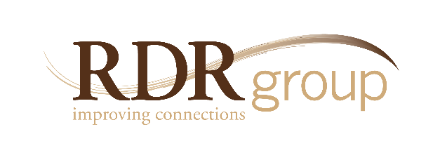

Bridging the Divide:
Developing Cultural Competency

5250 Grand Ave. • Ste.14 #206 Gurnee, IL • 60031-1877
Ph. 815-477-2330 • Fax 2335
www.rdrgroup.com

THE NEED
In a multi-cultural, multi-generational, and multifaceted world, what could be more strategic than developing a capacity to work with people of different beliefs, backgrounds, and experiences? In order to truly succeed in our interactions with customers, co-workers and the community at large, it is critical to understand how someone else might think or behave so we can maximize our outcomes with those individuals. These are not necessarily skills that come naturally—but once they are learned and practiced, the result is increased personal success, increased employee engagement, and increased customer satisfaction.

The Culture Competency Workshops are customized learning modules that are tailored to meet specific needs and create greater understanding around various identity groups. For example, sessions have been created to address issues like:
- Generational differences
- Sexual orientation
- Ethnic differences
- Gender differences
- Religious differences

Introduction: The Importance of Being
a Bridge Builder
The stage is set for mutual understanding as an
organizational imperative and fundamental “life skill”
to ensure personal and organizational success.

- Hearing the Other Side
- An opportunity is provided for participants to voice perspectives, concerns, and challenges as representatives of their particular identity group. This allows each individual to express their opinions in a safe and structured way within the framework of building better connections and stronger relationships.
- Identifying Differences
- Group norms and cultural tendencies are discussed from the perspective of archetypal data that is carefully presented as information

describing the general patterns of a particular identity group (as it might apply to age, ethnicity, sexual orientation, gender, religion, etc.). There is also explicit acknowledgement that not everyone follows the norm.
- Various cultural dimensions are explored in the different workshops, such as:
  - Different communication styles based on gender
  - Different beliefs based on religion
  - Different perspectives based on sexual orientation
  - Different customs based on ethnicity
  - Different work styles based on age

- Hot Buttons Explored
- Participants are divided into respective groups and asked to make a list of ways they feel misunderstood. Specifically, they are asked to identify comments or behaviors that they would consider challenging, and to locate their group’s “hot buttons”—with the aim of helping other groups understand why these items are challenging for them.

- Retention Issues Surrounding Various Identity Groups
- Discussion of recruiting practices in reference to particular identity groups
- Discussion of career planning in reference to particular identity groups
- Giving and receiving feedback in reference to particular identity groups
- Recognition and rewards in reference to particular identity groups

- Marketing Issues Surrounding Various Identity Groups
- Marketing efforts as they apply to particular identity groups
- Product lines as they apply to particular identity groups
- Community involvement as it applies to particular identity groups
- Customer service as it applies to particular identity groups

Conclusion: Bridging the Gap
A discussion of specific action plans to close the gender, ethnic, religious, lifestyle, and generational gaps are developed by the participants from both a personal and organizational perspective. Also, additional resources for continued learning and growth are recommended.

