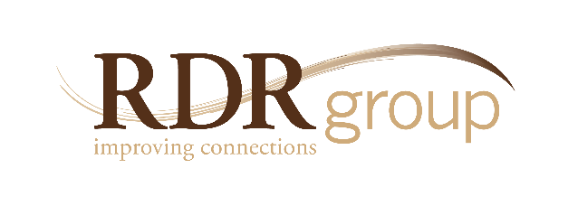

Achieving Exceptional Results:
Leading Yourself and Others to Greater Success

5250 Grand Ave. • Ste.14 #206 Gurnee, IL • 60031-1877
Ph. 815-477-2330 • Fax 2335
www.rdrgroup.com

THE FOCUS
What makes certain people so successful?
What makes a leader effective?
What makes an organization great?
THE DIFFERENCE
At some stage, everyone ends up attending a development or leadership course—but this workshop is based on proven competencies… not inspirational platitudes. It is also not restricted to leaders, because getting “faster, smarter, strong” requires that everyone in the organization take ownership to create commitment and accountability.

CONTRASTING MODELS OF ACHIEVEMENT

Few organizations tap into the full range of capabilities residing in both their leaders and individual contributors. Even fewer know how to expand those capabilities for everyone. The false notion that only a select group can be exceptional is at the heart of their failure to accomplish “more with less,” and as a result, they limit their own success.

These are critical questions for everyone today because the rules have changed, and just being good is no longer “good enough.” Every individual, every team, and every organization must become better—because the difference between acceptable and exceptional is definitive. This workshop zeroes in on the beliefs and practices that current research verifies as indisputably effective in Achieving Exceptional Results.

SELECTION THEORY IS A DEAD END

The myth about Achieving Exceptional Results is that organizations need to be in the business of selecting gifted people; when those people don’t live up to expectations, the explanation is that “something must be wrong with the selection process.” The resulting strategy: “Can’t someone please hire better people?”

*This approach has dominated the landscape for ages, but the data regarding high achievement points us in another direction.
The difference between the myth and the truth is radical. Selection Theory generates frustration and the under-utilization of the organizations most critical resource. Expansion Theory generates significantly better outcomes, a sense of purpose, and personal responsibility. Ironically, the theory that is the least productive is the most common—which makes it even more advantageous to get it right.

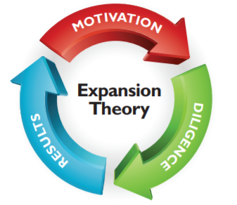

EXPANSION THEORY IS A LIMITLESS CYCLE

The truth about Achieving Exceptional Results is that those willing to try can expand their capabilities through a process of consistent development. This model focuses on helping everyone get better and the resulting strategy is, “What else can I do to lead myself and others to greater and greater levels of achievement?”

*This approach can revolutionize a workforce if it is applied.

THE MAIN COMPONENTS OF ACHIEVEMENT

Participants explore the mechanics of Expansion Theory, and experience how development happens by means of a powerful simulation. The main components include:
- Motivation – participants examine what motivates human beings, what people tend to believe about themselves and others and how to make proper attributions for success.
- Diligence – this involves a discussion of what deliberate practice looks like, how to structure assignments for development and how to use feedback for growth.

THREE ACHIEVEMENT AREAS

With an Expansion Theory approach, participants are asked to consider what “greater success” might look like for them in three Achievement Areas, and then begin to apply the development process where it matters most.
- Self Development requires being aware of what you are good at, while acknowledging what you still have to learn. Competencies for this Achievement Area include, but are not limited to:
- Self-Assessment – personal examination of competency levels, plus a look at personal style and how it impacts the ability to Achieve Exceptional Results.
- Tenacity – harnessing the ability to remain focused and resolute in the face of obstacles,
and even turn obstacles into opportunities.

*[Clients can add integrity, maturity, or any number of other desired competencies.]

- Team Development requires knowing how to interact, motivate, and assist fellow team members. People who want to achieve at the highest levels have to be serious about helping others achieve as well—especially those in leadership positions (with an understanding that leadership is not restricted by position or title). Competencies for this Achievement Area include, but are not limited to:
- Development Coaching and Motivating Others – understanding and appreciating differences in styles, needs, and responses to leadership.

*[Clients can add connecting, communicating, vision-casting, or
any number of other identified competencies.]

- Organizational Development requires that everyone within the organization understands the importance of their contribution to the overall mission. At the end of the day, all individual and team-based improvement must benefit the larger organization or it is missing the target. Competencies for this Achievement Area include, but are not limited to:
- Business Acumen – organizational success, and indeed survival, is dependent on strategic knowledge that transcends individuals and departments.
*[Clients can add service excellence, systems thinking, or any number of other identified competencies.]

CONCLUSION
In closing out the session, participants are asked to work on a game plan for continuous improvement. Action items are created, and everyone leaves with a development plan for greater success in the Achievement Areas of self development, team development, and organizational development—with a commitment to specific Achievement Competencies.

Workshop Format
The workshop can be customized with a focus on the Achievement Competencies most critical to your organization, and the format is flexible (from half-day modules to extended timeframes of a day or more, especially for leaders where more depth is required).

